WEB APPLICATION FOR MAGIZH MEDICAL

A PROJECT WORK
Submitted by
Naveen A
23ADR116
Kowshick P
23ADR093
Nishanth P
23ADR120
in partial fulfilment of the requirements for
the award of the degree of
BACHELOR OF TECHNOLOGY
IN
ARTIFICIAL INTELLIGENCE AND DATA SCIENCE
DEPARTMENT OF ARTIFICIAL INTELLIGENCE AND DATA SCIENCE
KONGU ENGINEERING COLLEGE
(Autonomous)
PERUNDURAI ERODE – 638 060
MARCH 2026
WEB APPLICATION FOR MAGIZH MEDICAL

A PROJECT WORK
Submitted by
Naveen A
23ADR116
Kowshick P
23ADR093
Nishanth P
23ADR120
in partial fulfilment of the requirements for
the award of the degree of
BACHELOR OF TECHNOLOGY
IN
ARTIFICIAL INTELLIGENCE AND DATA SCIENCE
DEPARTMENT OF ARTIFICIAL INTELLIGENCE AND DATA SCIENCE
KONGU ENGINEERING COLLEGE
(Autonomous)
PERUNDURAI ERODE – 638 060
MARCH 2026
DEPARTMENT OF ARTIFICIAL INTELLIGENCE AND DATA SCIENCE
KONGU ENGINEERING COLLEGE
(Autonomous)
PERUNDURAI ERODE – 638060
MARCH 2026

BONAFIDE CERTIFICATE
This is to certify that the project report entitled Web Application For Magizh Medical is the bonafide record of project work done by Naveen A (Reg.No: 23ADR116), Kowshick P (Reg.No: 23ADR093), Nishanth P (Reg.No: 23ADR120) in partial fulfilment of the requirements for the award of the Degree of Bachelor of Technology in Artificial Intelligence and Data Science of Anna university Chennai during the year 2025 - 2026.

SUPERVISOR HEAD OF THE DEPARTMENT Date: (Signature with seal)

Submitted for the end semester viva voce examination held on ___________

INTERNAL EXAMINER EXTERNAL EXAMINER
DEPARTMENT OF ARTIFICIAL INTELLIGENCE AND DATA SCIENCE
KONGU ENGINEERING COLLEGE
(Autonomous)
PERUNDURAI ERODE – 638060
MARCH 2026
DECLARATION
We affirm that the Project Report titled Web Application For Magizh Medical being submitted in partial fulfilment of the requirements for the award of Bachelor of Technology is the original work carried out by us. It has not formed the part of any other project report or dissertation on the basis of which a degree or award was conferred on an earlier occasion on this or any other candidate.
Date:
NAVEEN A
(23ADR116)

KOWSHICK P
(23ADR093)

NISHANTH P
(22ADR113)

I certify that the declaration made by the above candidate is true to the best of my knowledge.

Date: Name and Signature of the Supervisor

ABSTRACT
The project Web Application For Magizh Medical is a comprehensive full-stack web application developed to revolutionize pharmacy operations through digital transformation and AI-powered inventory management. Traditional pharmacy management often relies on manual record-keeping and disconnected systems, making it challenging to accurately track medicine stock levels, monitor expiry dates, and manage billing processes efficiently. This system provides a centralized digital platform that enables pharmacies to manage inventory workflows more effectively while improving transparency across all operational aspects.
The platform supports essential pharmacy operations including multi-batch inventory tracking with automated expiry monitoring, real-time low stock alerts, automated billing with unique bill number generation, and intelligent stock deduction. Users can record medicine batches with different expiry dates, track stock movements, process customer bills with automatic price calculation, and monitor inventory levels through an integrated interface. By digitizing these processes, the system reduces manual errors, improves data accessibility, and ensures that pharmaceutical stock information is available in real time.
In addition to operational management, the system integrates artificial intelligence components using Groq (Llama 3.1 8B) to analyze inventory data and provide intelligent stock enquiry capabilities. The AI chatbot evaluates real-time medicine availability, expiry status, and stock levels through natural language queries, generating context-aware responses with markdown-formatted tables sorted by urgency. By combining comprehensive pharmacy management with intelligent analytics and automated billing, the platform enhances operational efficiency, reduces medicine wastage, and supports data-driven decision-making in modern pharmaceutical retail environments.

ACKNOWLEDGEMENT
We express our sincere thanks and gratitude to Thiru. E. R. K. Krishnan M.Com. , our beloved Correspondent, and all other philanthropic trust members of Kongu Vellalar Institute of Technology Trust who have always encouraged us in academic and co-curricular activities.
We are extremely thankful with no words of a formal nature to the dynamic Principal Dr. R. Parameshwaran M.E., Ph.D., for providing the necessary facilities to complete our work.
We would like to express our sincere gratitude to our respected Head of the Department Dr. P. Natesan M.E., Ph.D., for providing the necessary facilities.
We extend our thanks to our project coordinator Dr. K. S. Kalaivani M.E., Ph.D., Associate Professor, Department of Artificial Intelligence and Data Science, for her encouragement and valuable advice that made us carry out the project work successfully.
We extend our gratitude to our Supervisor Mrs. R. Thangamani M.E., Assistant Professor, Department of Artificial Intelligence and Data Science, for her valuable ideas and suggestions, which have been very helpful in the project. We are grateful to all the faculty members of the Artificial Intelligence Department, for their support.

REQUISITION LETTER
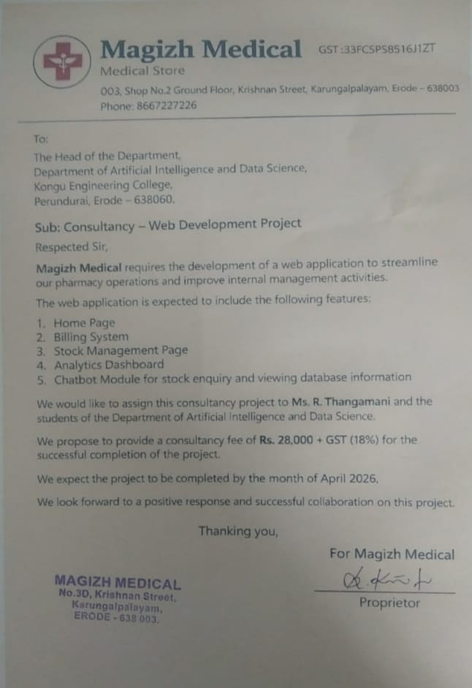

TABLE OF CONTENTS

CHAPTER No. | TITLE | PAGE No.
 | ABSTRACT | II
 | LIST OF FIGURES | VI
 | LIST OF ABBREVIATIONS
1 | INTRODUCTION
 | 1.1 General
 | 1.2 Background of the Study
 | 1.3 Problem Statement
 | 1.4 Objectives of the Project
 | 1.5 Scope of the Project
 | 1.6 Organization of the Report
2 | LITERATURE REVIEW | 5
 | 2.1 General | 5
 | 2.2 Digital Production Monitoring Systems | 6
 | 2.3 Artificial Intelligence in Manufacturing | 7
 | 2.4 Inventory Management Systems
 | 2.5 Summary of Literature Review
3 | SYSTEM ANALYSIS | 8
 | 3.1 Existing System | 8
 | 3.2 Limitations of Existing System | 9
 | 3.3 Proposed System | 10
 | 3.4 Feasibility Study
 | 3.5 System Requirement Analysis
4 | SYSTEM DESIGN | 22
 | 4.1 System Architecture | 22
 | 4.2 Database Design
 | 4.3 Workflow Design
 | 4.4 User Interface Design
5 | SYSTEM IMPLEMENTATION
 | 5.1 Implementation Overview
 | 5.2 Frontend Implementation
 | 5.3 Backend Implementation
 | 5.4 Database Implementation
 | 5.5 AI Analytics Module Implementation
6 | SYSTEM TESTING
 | 6.1 Testing Strategy
 | 6.2 Test Cases
 | 6.3 Results and Discussion

7 | CONCLUSION AND FUTURE ENHANCEMENTS
 | 7.1 Conclusion
 | 7.2 Future Enhancements
 | APPENDICES
 | REFERENCES
 | MAPPING OF PROJECT GOALS TO SDG

LIST OF FIGURES

FIG No. | TITLE | PAGE No.
4.1 | System Architecture Diagram | 24
4.2 | Flow Diagram | 25
4.3 | Use Case Diagram | 27
4.4 | Sequence Diagram | 29
4.5 | Database Schema / Design Diagram | 31
A2.0 | Login / Signup Page | 74
A2.1 | Customer Table Selection Page | 74
A2.2 | Home Page | 75
A2.3 | Categories Page | 75
A2.4 | Products / Menu Page | 75
A2.5 | Search Results Page | 76
A2.6 | Cart Page | 76
A2.7 | Wishlist / Favorites Page | 77
A2.8 | Checkout / Payment Page | 77

A2.9 A2.9 | Order Confirmation Page | 78
A2.10 | Chef Dashboard Page | 78
A2.11 | Chef Order Management Flow | 78
A2.12 | Chef Feedback Summary Section | 79
A2.13 | Admin Dashboard | 79
A2.14 | Admin – Menu Management Page | 80
A2.15 | Admin – Table Reservation Page | 80
A2.16 | Guest Dashboard Page | 81
A2.17 | Guest Reservation Page & Table View | 81
A2.18 | Guest Menu Browsing Page | 81

CHAPTER 1

INTRODUCTION
In recent years, pharmaceutical retail operations have increasingly adopted digital technologies to improve accuracy, efficiency, and customer service quality. Traditional pharmacy management methods often rely on manual record keeping to track medicine inventory, process customer bills, and monitor stock expiry dates. These manual methods are time-consuming, prone to human errors, and make it difficult for pharmacy owners to obtain real-time insights into stock levels and sales performance. As healthcare retail moves toward digital transformation, web-based management systems have become essential tools for improving transparency and decision-making within pharmacy environments.
The project titled Web Application For Magizh Medical focuses on developing a digital platform designed specifically for retail pharmacy operations. The system provides an integrated environment where medicine inventory, billing transactions, stock information, and customer data can be managed through a centralized web interface. By digitizing these processes, the system helps pharmacy staff track medicine batches efficiently while maintaining accurate records of stock movements and sales activities.
The application combines modern web development technologies with Artificial Intelligence based analytics to create an intelligent pharmacy management solution. Through this platform, pharmacy managers can easily view stock statistics, manage medicine inventory across multiple batches, and analyze sales performance. The system ultimately aims to enhance efficiency, reduce manual workload, and support data-driven decision making in pharmaceutical retail environments.

1.1 BACKGROUND OF THE STUDY
Pharmaceutical retail industries play an important role in the healthcare supply chain by ensuring medicine availability to patients and customers. In these pharmacies, large quantities of medicines pass through multiple stages including procurement, batch tracking, storage, dispensing, and billing before reaching the end consumers. Managing these operations requires careful coordination between inventory resources, expiry monitoring, and customer service to ensure smooth pharmacy workflow and patient satisfaction.
However, many small and medium-scale pharmacy units still depend on manual registers, spreadsheets, or fragmented digital tools to record medicine transactions and stock information. This approach often results in inconsistent data management and difficulty in tracking medicine batches across different storage locations. Pharmacy staff may find it challenging to identify low-stock items, monitor expiry dates, or maintain accurate records of medicine availability and pricing information.
With the advancement of digital technologies and AI-powered solutions, there is a growing need for intelligent systems capable of monitoring pharmacy operations in real time. Web-based management platforms combined with data analytics can provide valuable insights into sales performance and inventory efficiency. Implementing such systems in pharmaceutical retail can significantly improve stock planning, resource allocation, and customer service delivery.

1.2 PROBLEM STATEMENT
Retail pharmacies often operate in environments where production data and inventory information are recorded manually or stored in disconnected systems. This lack of centralized monitoring makes it difficult for pharmacy managers to obtain a clear overview of ongoing stock levels and sales activities. Without a unified platform, tracking the quantity of medicines entering and leaving inventory becomes complicated, and errors in stock records may lead to inefficiencies in serving customer needs.
Another major challenge is the absence of analytical tools that can interpret inventory data and provide meaningful insights. Pharmacy managers typically rely on experience or manual calculations to make operational decisions, which may not always reflect the actual performance trends of the business.
Therefore, there is a need for a comprehensive digital solution that can integrate inventory monitoring, automated billing, and intelligent data analysis into a single system. Such a platform would help pharmacy administrators maintain accurate records, monitor operations efficiently, and utilize AI-based insights to improve productivity and operational control.

1.3 OBJECTIVES OF THE PROJECT
The primary objective of the Web Application For Magizh Medical is to develop a centralized digital platform that simplifies the monitoring and management of pharmacy operations within a retail medical store. The system aims to replace traditional manual record-keeping methods with an efficient web-based solution that allows administrators and staff to track inventory progress in real time.
Another important objective is to improve inventory management by maintaining accurate records of medicine quantities entering and leaving the pharmacy through sales transactions. The system enables pharmacy personnel to manage medicine batches with different expiry dates while maintaining clear visibility of stock availability and pricing status.
The project also focuses on integrating Artificial Intelligence based analytics using Groq AI to support business decision making. By analyzing historical sales data and operational patterns, the AI component can generate insights that help managers identify sales trends, optimize stock allocation, and improve overall workflow efficiency. Through these features, the system contributes to the digital transformation of traditional pharmaceutical retail processes.

1.4 SCOPE OF THE PROJECT
The scope of this project is focused on designing and implementing a web-based pharmacy management system tailored for retail medical stores. The platform allows pharmacy administrators and supervisors to manage inventory activities through an intuitive dashboard where key operational data is displayed in an organized manner. The system enables users to record medicine details, track batch expiry dates, and monitor stock levels across different categories of pharmaceutical products.
The project also includes the development of a basic Artificial Intelligence module capable of analyzing stored inventory data to generate useful business insights. These insights assist managers in understanding sales trends and identifying potential improvements in workflow efficiency. Although the current system is designed for retail pharmacies, the overall architecture can be adapted for other healthcare environments that require inventory monitoring and billing management.
Future expansions of the system may include integration with supplier databases, mobile application support, and advanced predictive analytics to further enhance the monitoring capabilities of the platform.

1.5 ORGANIZATION OF THE REPORT
This project report is organized into several chapters to clearly present the development and implementation of the Web Application For Magizh Medical. Each chapter describes a specific stage of the system development process, beginning with the conceptual background and progressing toward the final implementation and evaluation of the system.
The first chapter introduces the project by explaining the background, problem statement, objectives, and scope of the proposed system. The second chapter presents a literature review of existing research and technologies related to pharmacy management systems, inventory tracking solutions, and Artificial Intelligence applications in healthcare retail industries.
The third chapter focuses on system analysis, where the existing system is examined and the proposed solution is discussed in detail. The fourth chapter describes the system design, including architecture diagrams, data flow diagrams, and database design. The fifth chapter explains the implementation process and technologies used in developing the system. The sixth chapter discusses system testing and evaluation, while the final chapter summarizes the outcomes of the project and suggests possible future enhancements.

CHAPTER 2
SYSTEM ANALYSIS
2.1 EXISTING SYSTEM
In many small and medium scale pharmaceutical retail pharmacies, inventory and sales activities are still monitored using manual methods such as paper registers, spreadsheets, or basic record keeping systems. In a typical medical store, different operations including medicine procurement, stock storage, expiry tracking, and billing are handled separately. Pharmacy staff often record transaction details manually at each stage and later compile the data for reporting purposes.
This traditional approach makes it difficult to maintain accurate records of medicine movement across various storage locations and sales counters. Pharmacy managers may face challenges in tracking how much stock has been sold, how much inventory is available, and which medicines are approaching their expiry dates. Because information is scattered across different records, obtaining a clear overview of pharmacy operations becomes time consuming.
Another limitation of the existing system is the absence of real-time monitoring. Managers often receive inventory and sales updates only after manual reports are prepared, which delays decision making. This lack of timely information may result in inefficient resource allocation, stockouts or overstocking, expired medicine losses, and difficulty in identifying operational problems within the pharmacy.
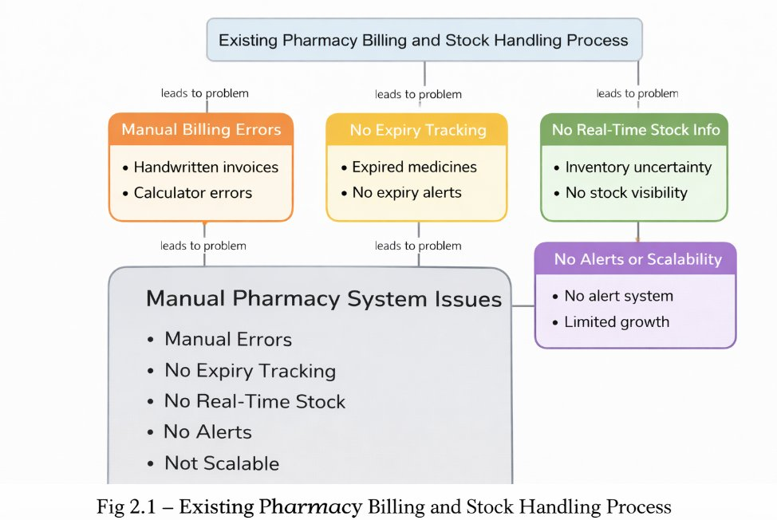
FIGURE 2.1. EXISTING PHARMACY BILLING AND STOCK HANDLING PROCESS
2.2 LIMITATIONS OF THE EXISTING SYSTEM
Although manual monitoring methods have been used for many years, they present several challenges in modern pharmaceutical retail environments. One of the major limitations is the lack of centralized data management. Since inventory and sales records are maintained in separate registers or files, it becomes difficult to consolidate information and obtain a complete view of pharmacy operations.
Manual record keeping is also prone to human errors. Mistakes in recording medicine quantities, pricing details, batch numbers, or expiry dates may lead to inaccurate reports and poor decision making. In addition, retrieving historical sales data or inventory records becomes difficult when records are stored in physical formats.
Another significant limitation is the absence of analytical tools that can evaluate sales performance and inventory trends. Pharmacy managers rely mainly on manual calculations and experience to analyze operational patterns, which may not always provide accurate insights. Without proper analytics, it is difficult to identify productivity improvements, optimize stock levels, or predict future inventory requirements.
These limitations highlight the need for a digital management system capable of automating inventory tracking, billing processes, and providing reliable insights for pharmacy operations.
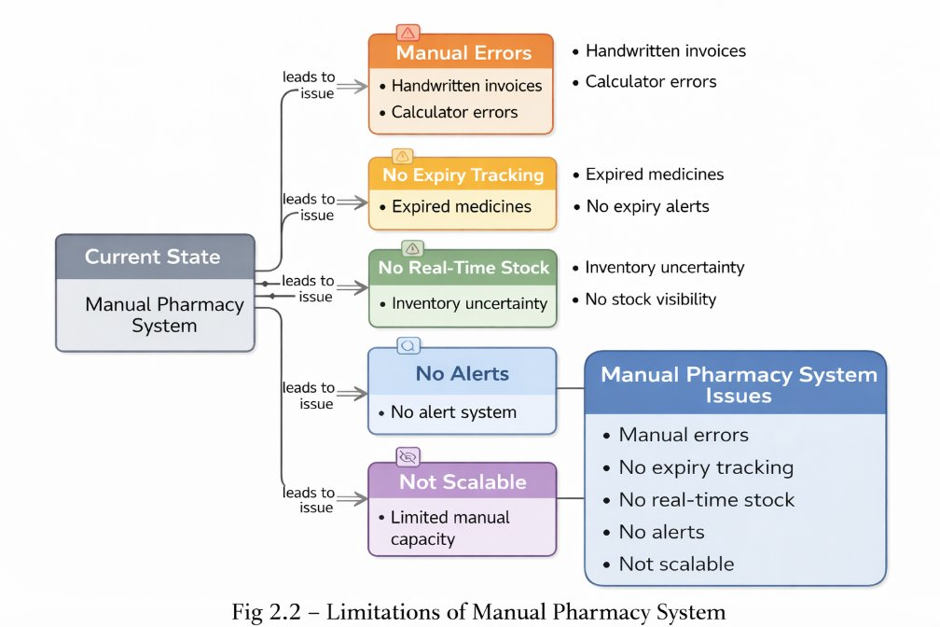
FIGURE 2.2. LIMITATIONS OF MANUAL PHARMACY SYSTEM
2.3 PROPOSED SYSTEM
overcome the limitations of the existing system, the proposed project introduces the Web Application For Magizh Medical. The system is designed as a web-based platform that allows pharmacy administrators and staff to digitally monitor inventory activities, process customer bills, and manage medicine information through a centralized dashboard.
In the proposed system, inventory data, sales transactions, and medicine information from different sections of the pharmacy is recorded through an online interface. This data is stored in a structured database, making it easier to access, update, and analyze pharmacy information. Managers can view real-time updates regarding stock levels, medicine expiry dates, sales performance, and overall pharmacy operations through the system dashboard.
An important feature of the proposed system is the integration of Artificial Intelligence based analytics using Groq AI. The AI component analyzes stored inventory and sales data to identify patterns and generate insights that help managers make better operational decisions. For example, the system can analyze sales trends and suggest improvements in stock procurement, or respond to natural language queries about medicine availability through an intelligent chatbot interface.
By combining inventory management, automated billing, and intelligent AI-powered analytics, the proposed system provides a comprehensive solution that improves operational transparency and enhances pharmacy productivity.
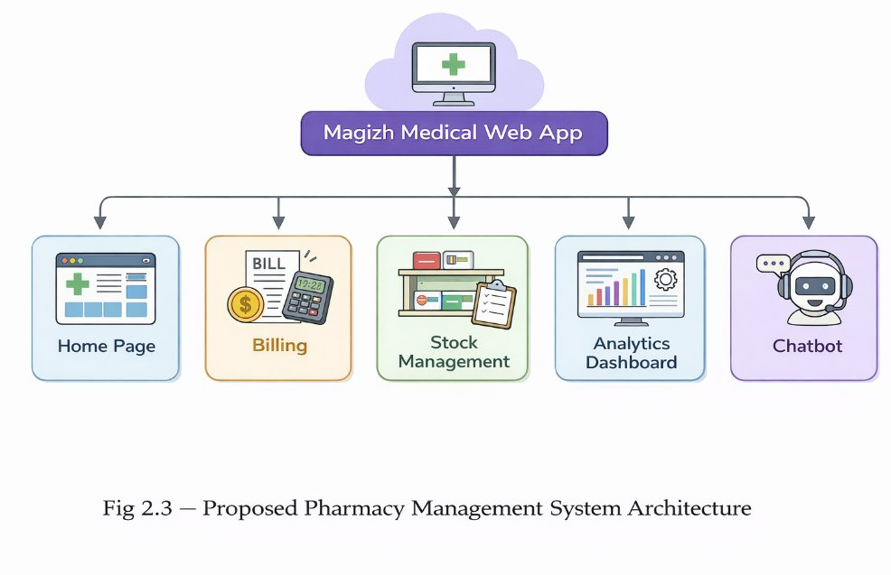
FIGURE 2.3. PROPOSED PHARMACY MANAGEMENT SYSTEM ARCHITECTURE
2.4 FEASIBILITY STUDY
Before implementing the proposed system, it is important to evaluate whether the system is practical and beneficial for the organization. A feasibility study helps determine the technical, economic, and operational viability of the project.
Technical Feasibility
The proposed system can be developed using modern web technologies such as React.js for frontend, Node.js and Express.js for backend, MongoDB for database management, and Groq SDK for AI integration. These technologies are widely available and provide reliable platforms for developing scalable web applications. Therefore, implementing the system is technically feasible.
Economic Feasibility
The system does not require expensive hardware or specialized infrastructure. Since it is developed as a web-based platform, it can operate on standard computers and devices used within the pharmacy. The cost of development and deployment is relatively low compared to the potential benefits such as improved efficiency, reduced medicine wastage, and reduced manual workload.
Operational Feasibility
The system is designed with a simple and user-friendly interface that allows pharmacy administrators and staff to easily record and monitor inventory, process bills, and manage medicine information. Because it replaces manual record keeping with a digital platform, it simplifies operational processes and improves productivity within the pharmacy.
2.5 SYSTEM REQUIREMENT ANALYSIS
System requirement analysis identifies the hardware and software components necessary for implementing the proposed system. These requirements ensure that the system operates efficiently and meets the functional needs of the pharmacy.

Hardware Requirements
The system requires standard computing devices such as desktop computers, laptops, or tablets with internet connectivity. These devices will be used by pharmacy administrators and staff to access the management platform. A reliable internet connection is required for cloud-based data access and AI chatbot functionality.
Software Requirements
The application is developed using modern web development technologies including React.js with TypeScript for the user interface, Node.js and Express.js for backend server processing, and MongoDB for database management. An AI module powered by Groq API (Llama 3.1 8B model) is integrated to analyze inventory data and generate business insights through natural language interactions. Additional libraries include Mongoose for database modeling, TailwindCSS for responsive design, and Shadcn/ui components for enhanced user experience.
By fulfilling these hardware and software requirements, the proposed system can provide an effective digital platform for monitoring inventory, managing billing operations, and optimizing pharmacy workflows at Magizh Medical.

CHAPTER 3

SYSTEM DESIGN

3.1 SYSTEM ARCHITECTURE
System architecture describes the overall structure of the proposed application and how different components interact with each other. The Web Application For Magizh Medical follows a web-based architecture that connects the user interface, application server, database, and AI analytics module. This architecture allows users to access the system through a web browser while all data processing and storage operations are handled by the backend server and database.
In the proposed system, pharmacy administrators and staff interact with the platform through a web dashboard. The user interface provides forms and visualization panels that allow users to enter medicine inventory data, process customer bills, track expiry dates, and query stock availability through an AI chatbot. The frontend communicates with the backend server through application programming interfaces (APIs) that handle user requests and process data transactions.
The backend server is responsible for managing business logic, inventory operations, billing calculations, and communication with the database. Medicine records, batch information, sales transactions, and billing history are stored in a structured MongoDB database where they can be retrieved whenever required. An Artificial Intelligence module powered by Groq API is integrated with the system to analyze stored inventory data and generate insights that assist managers in making informed decisions about stock procurement and sales strategies.
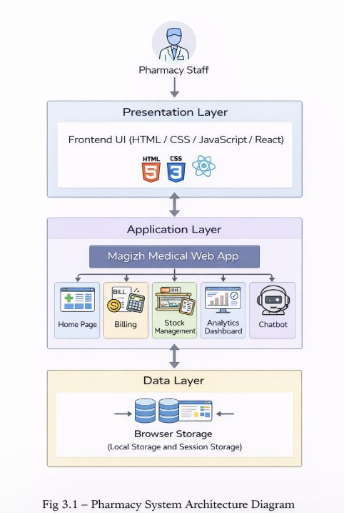
FIGURE 3.1. PHARMACY SYSTEM ARCHITECTURE DIAGRAM

3.2 DATABASE DESIGN
Database design is an essential part of the system because it determines how medicine inventory and sales information will be stored and retrieved. The proposed system uses a structured NoSQL database that organizes data into different collections or documents representing various entities involved in pharmacy operations.
The main entities in the system include medicine information with multiple batches, billing records, and transaction history. Each entity contains attributes that describe specific aspects of pharmacy activities. For example, medicine records include information such as medicine name, generic name, category, manufacturer, price, and multiple batch details with batch numbers, quantities, expiry dates, and purchase prices. Billing records maintain details about customer transactions including bill number, patient information, items purchased with batch tracking, quantities, prices, discounts, payment method, and transaction timestamps.
By structuring data in a well-organized database with embedded batch arrays and referenced billing items, the system ensures efficient storage and quick retrieval of information. This design also supports the AI analytics module, which relies on historical sales data and real-time inventory status to generate insights and recommendations for pharmacy management.

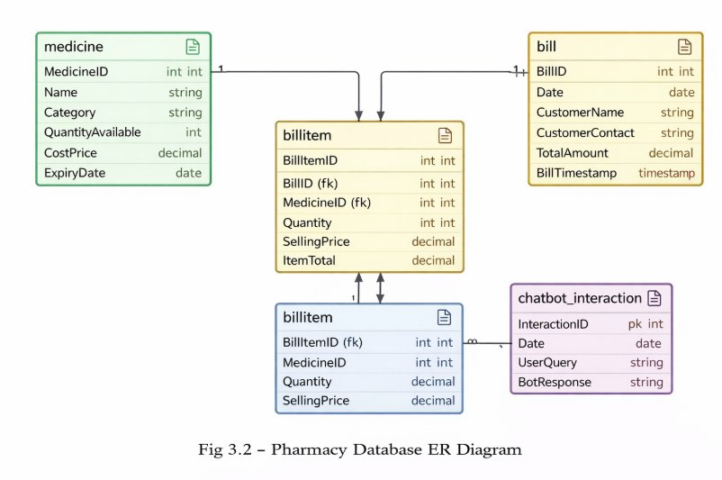
FIGURE 3.2. PHARMACY DATABASE ER DIAGRAM

3.3 WORKFLOW DESIGN
Workflow design describes the sequence of operations performed by the system to manage inventory tracking, billing processes, and AI-powered stock enquiries. The workflow begins when a user logs into the system through the web dashboard. After authentication, the user can enter medicine inventory details, add new batches with expiry information, or process customer billing transactions.
Once the data is submitted, the backend system processes the request and stores the information in the MongoDB database. The stored data is then used to update inventory dashboards, stock status indicators, and low-stock alerts displayed on the user interface. This allows pharmacy managers to observe pharmacy operations in real time and maintain accurate records of medicine movement and sales activities.
The AI analytics module powered by Groq AI periodically analyzes stored inventory and sales data to identify trends and patterns that can assist managers in improving operational efficiency. These insights are presented through an interactive chatbot interface that responds to natural language queries about medicine availability, expiry status, and stock levels. The system automatically deducts quantities from available batches when bills are created and generates unique bill numbers for each transaction.

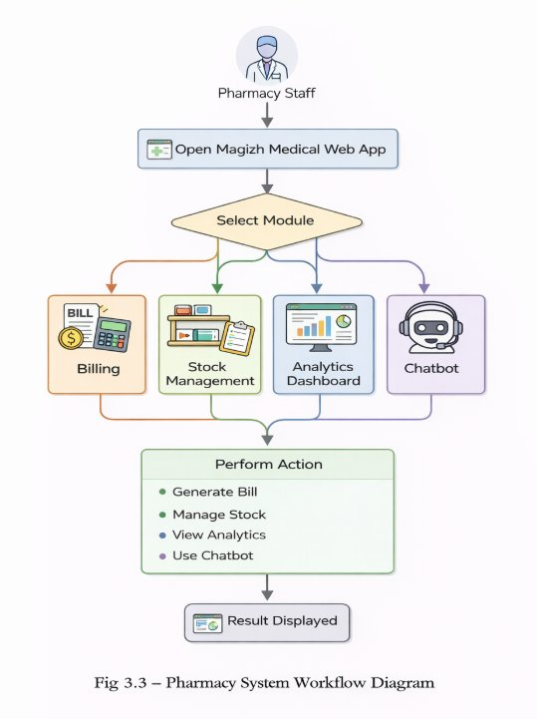
FIGURE 3.3. PHARMACY SYSTEM WORKFLOW DIAGRAM

3.4 USER INTERFACE DESIGN
The user interface design focuses on providing a simple and intuitive environment where pharmacy administrators and staff can easily interact with the system. Since the platform is designed as a web application, users can access it through any modern web browser without installing additional software. The interface includes dashboards, data entry forms, inventory tables, billing screens, and an AI chatbot panel that displays stock information and operational statistics.
The main dashboard provides a summary of pharmacy operations, including current stock levels, medicines near expiry, low-stock alerts, and recent billing activity. Users can navigate to different modules such as stock management, billing counter, AI chatbot enquiry, and reports through clearly organized menus with responsive navigation. Each module allows users to perform specific tasks while maintaining a consistent interface design with color-coded status indicators for expired, critical, warning, and good stock conditions throughout the system.
A well-designed user interface improves system usability and reduces the learning curve for pharmacy staff. By presenting inventory data, expiry information, and sales statistics in a clear and structured format with visual alerts and animations for urgent items, the interface helps managers quickly understand pharmacy conditions and take appropriate actions such as removing expired medicines or reordering low-stock items when necessary.
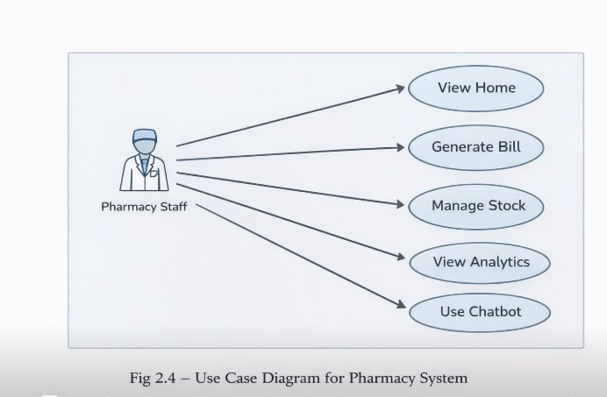
FIGURE 3.4. USE CASE DIAGRAM FOR PHARMACY SYSTEM

CHAPTER 4

SYSTEM IMPLEMENTATION
4.1 IMPLEMENTATION OVERVIEW
Implementation of the Web Application For Magizh Medical focuses on developing a web-based system that enables pharmacies to digitally monitor inventory activities and manage billing operations efficiently. The system integrates multiple modules such as stock management with multi-batch tracking, automated billing with stock deduction, expiry monitoring with visual alerts, and AI-based business analytics using Groq. By replacing traditional manual recording methods with a digital platform, the system improves accuracy, accessibility, and transparency in pharmacy operations.
The application is developed using a full-stack architecture where the React.js frontend interface communicates with the Node.js backend server to process requests and store information in MongoDB database. Users such as pharmacy administrators and staff can interact with the system through a web dashboard that allows them to enter medicine inventory data, add batches with expiry dates, process customer bills, and view analytics reports through an AI chatbot. This implementation ensures that all inventory and sales information is maintained in a centralized database that can be accessed whenever required.
The integration of an AI analytics component powered by Groq's Llama 3.1 8B model further enhances the system by analyzing inventory and sales data and generating useful insights through natural language conversations. These insights help administrators understand sales patterns, track medicine availability, and make better decisions regarding stock procurement and inventory management. As a result, the implemented system provides a practical solution for improving efficiency and decision-making in pharmaceutical retail environments.

4.2 FRONTEND IMPLEMENTATION
The frontend of the system is responsible for providing the user interface through which pharmacy administrators and staff interact with the application. It includes web pages and dashboards that allow users to enter medicine details, monitor stock levels with expiry tracking, process billing transactions, and query inventory information through an AI chatbot. The interface is designed with simplicity and usability in mind so that pharmacy staff can easily operate the system without requiring advanced technical knowledge.
The dashboard displays important operational information such as total medicines count, low-stock alerts, near-expiry warnings, and recent billing activity. Data entry forms are provided to record new medicine batches with batch numbers, quantities, expiry dates, and prices. These forms are connected to the backend server through REST APIs that transfer user inputs to the MongoDB database for storage and processing. The stock management page features color-coded status indicators and blinking animations for expired items to draw immediate attention.
In addition to data entry functions, the frontend also presents analytics results generated by the AI module through an interactive chatbot interface. Visual elements such as markdown-formatted tables, status emojis, and summary panels help administrators understand inventory trends and operational performance. The billing page automatically calculates totals, applies discounts, and generates unique bill numbers while deducting quantities from available batches. By presenting information in a clear and organized manner with responsive design, the frontend interface improves user experience and supports efficient monitoring of pharmacy operations.
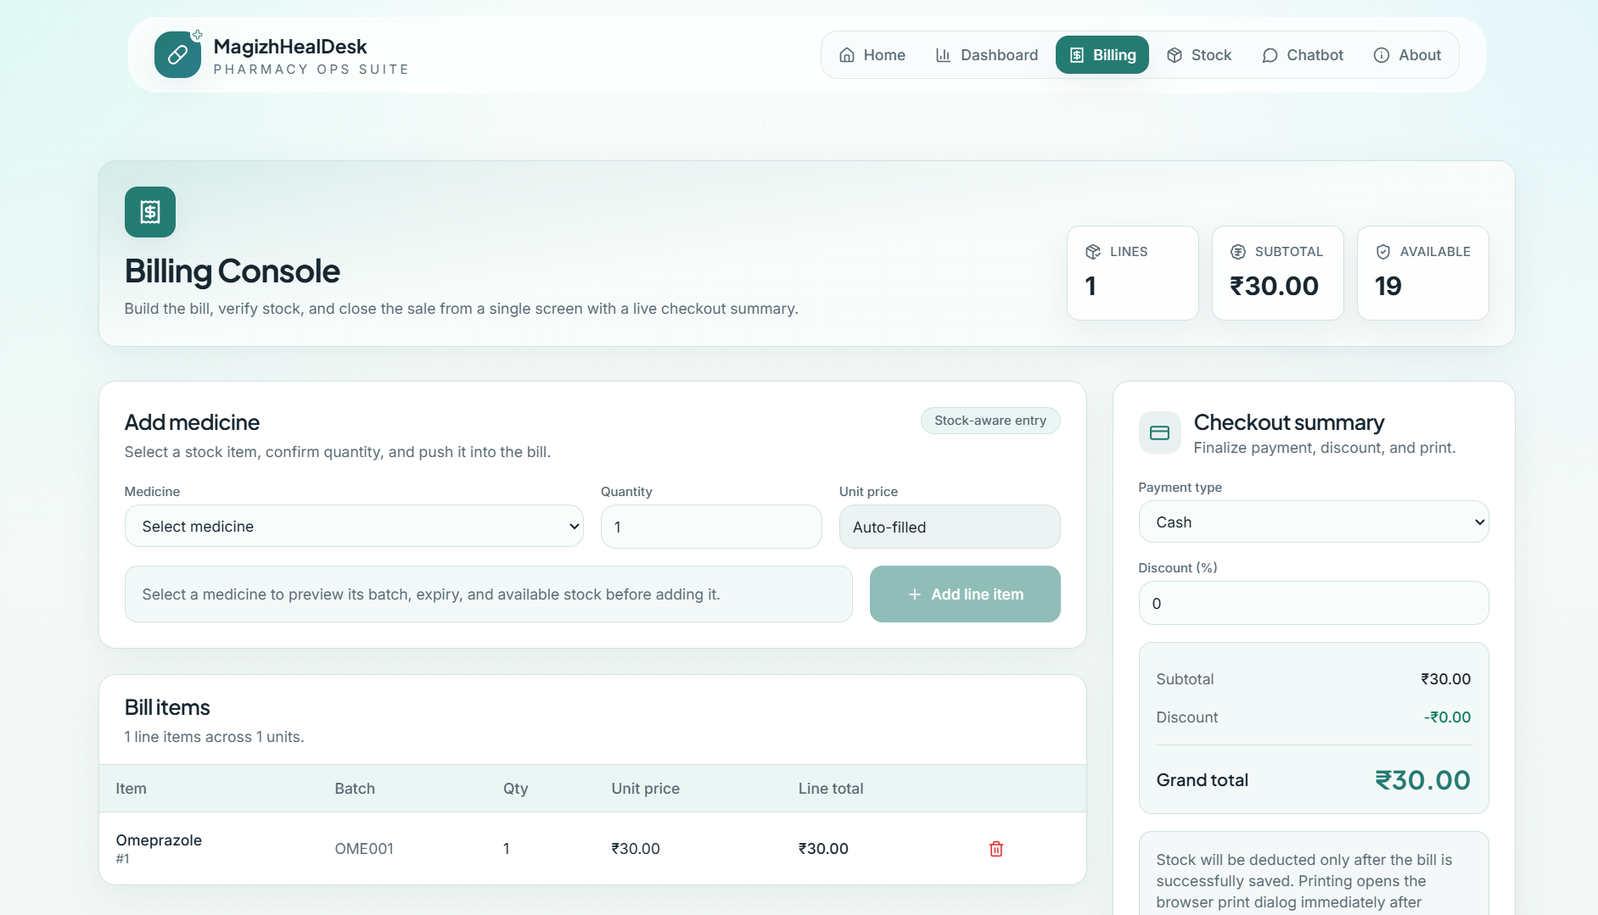
FIGURE 4.1. BILLING PAGE
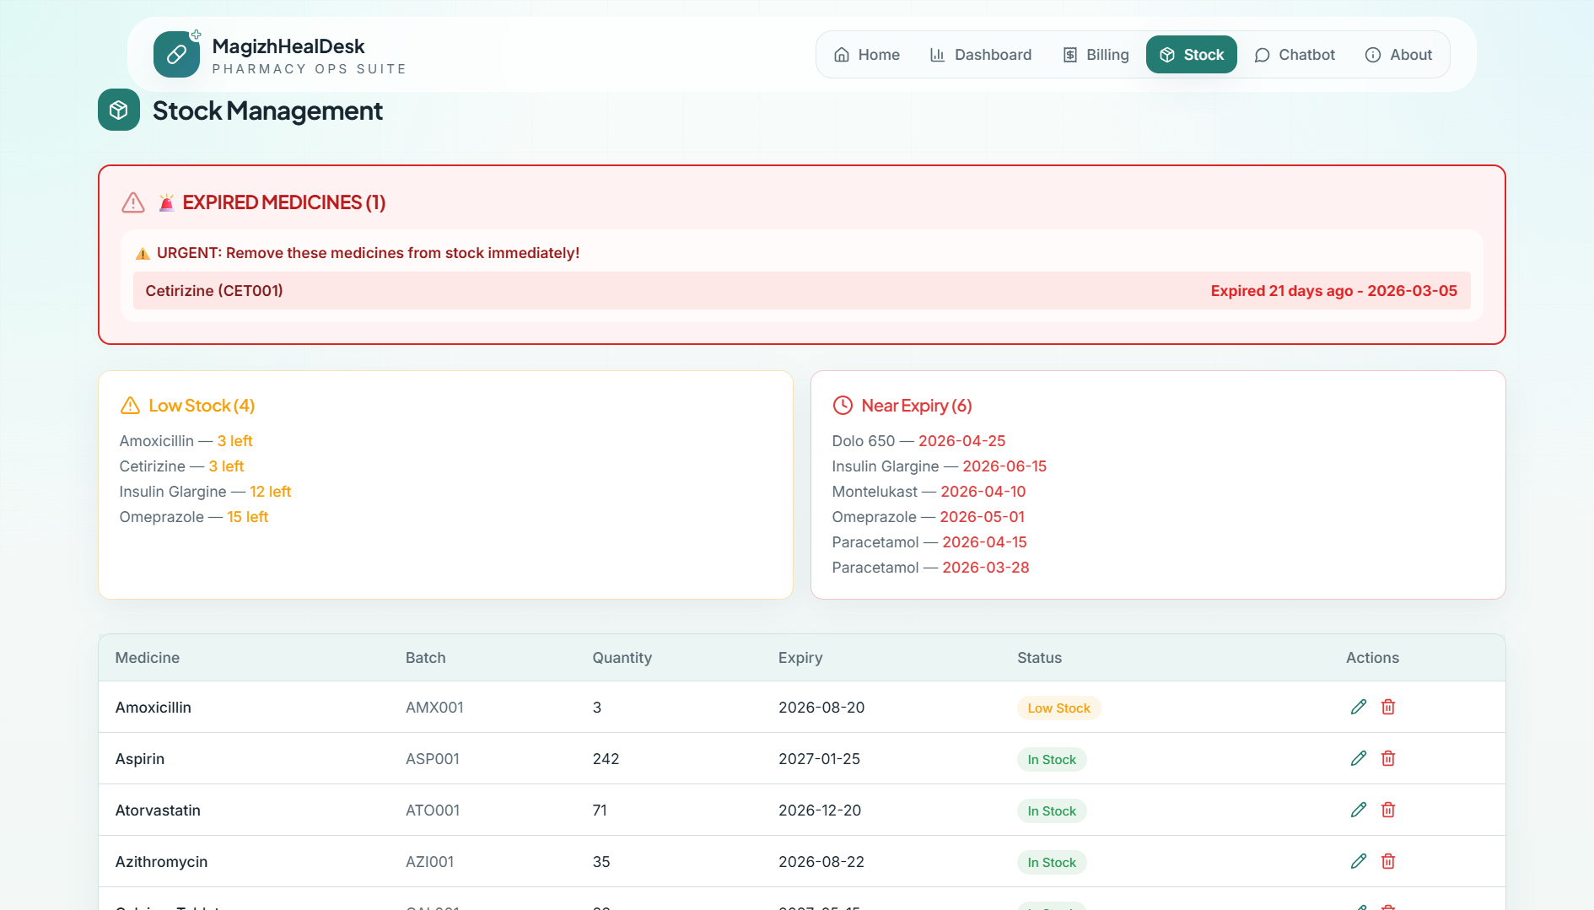
FIGURE 4.2. STOCK MANAGEMENT PAGE
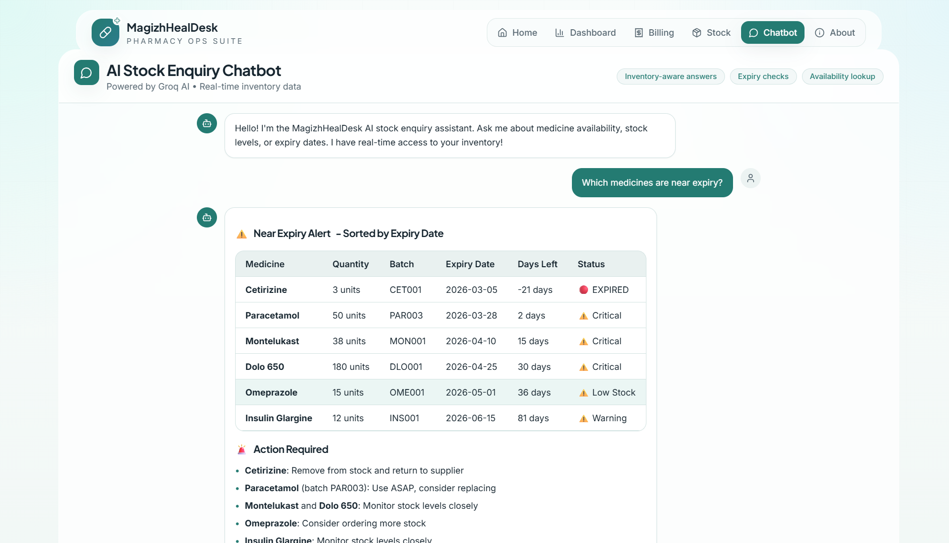
FIGURE 4.3. STOCK ENQUIRY CHATBOT PAGE
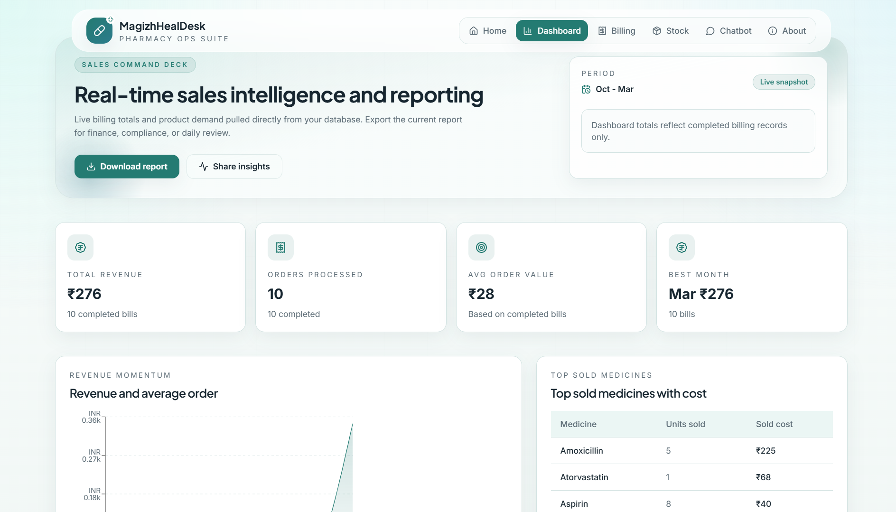
FIGURE 4.4. DASHBOARD PAGE
4.3 BACKEND IMPLEMENTATION
The backend implementation manages the core functionality of the system and handles communication between the user interface and the MongoDB database. It processes user requests, validates input data, and performs operations such as storing medicine records, updating batch quantities, processing billing transactions, and retrieving information for dashboard displays. The Express.js server acts as the central component that coordinates all activities within the application.
When a user submits medicine inventory or billing data through the frontend interface, the backend server receives the request and processes it according to predefined business logic. For billing operations, the system first validates stock availability across all batches using FIFO (First-In-First-Out) methodology, then creates the bill with auto-generated unique bill numbers and finally deducts quantities from the appropriate batches. The processed information is then stored in MongoDB, ensuring that all pharmacy activities are properly recorded. The backend also provides RESTful APIs that allow the frontend to retrieve data whenever administrators need to view inventory reports or sales history.
Another important responsibility of the backend system is managing the AI chatbot integration through Groq SDK. When users submit natural language queries, the backend fetches real-time inventory context, constructs intelligent prompts with current stock data sorted by expiry urgency, and sends requests to the Llama 3.1 8B Instant model. The backend also handles user session management and ensures secure API communication. By maintaining secure communication and organized data processing with proper error handling middleware, the backend implementation supports reliable operation of the pharmacy management platform.
4.4 DATABASE IMPLEMENTATION
The database plays a critical role in storing and organizing all information related to pharmacy inventory and billing operations. In the proposed system, MongoDB NoSQL database is designed to maintain structured documents of medicines with embedded batch arrays, billing transactions with itemized details, and user information. This organized document-based structure ensures that information can be retrieved quickly whenever required by the application.
Each medicine document recorded in the system contains details such as medicine name, generic name, category, manufacturer, price, low stock threshold, and an array of batches. Each batch sub-document includes batch number, quantity, expiry date, purchase date, and purchase price. Billing records maintain transaction details including auto-generated bill numbers, patient information, items array with medicine references, batch numbers, quantities, unit prices, totals, discounts, payment method, and timestamps. By linking these documents through object references and embedding related data, the system provides a comprehensive view of pharmacy operations and ensures that inventory and sales data remains consistent and accessible.
The database also supports the AI analytics module by storing historical sales data and real-time inventory status that can be analyzed to identify patterns and operational trends. Mongoose ODM is used for schema modeling with virtual fields for calculated values like total quantity across batches, low stock flags, and nearest expiry dates. Efficient database design with proper indexing ensures reliable storage of large volumes of pharmacy information while maintaining quick response times when users access the system or when the AI module queries current stock status.
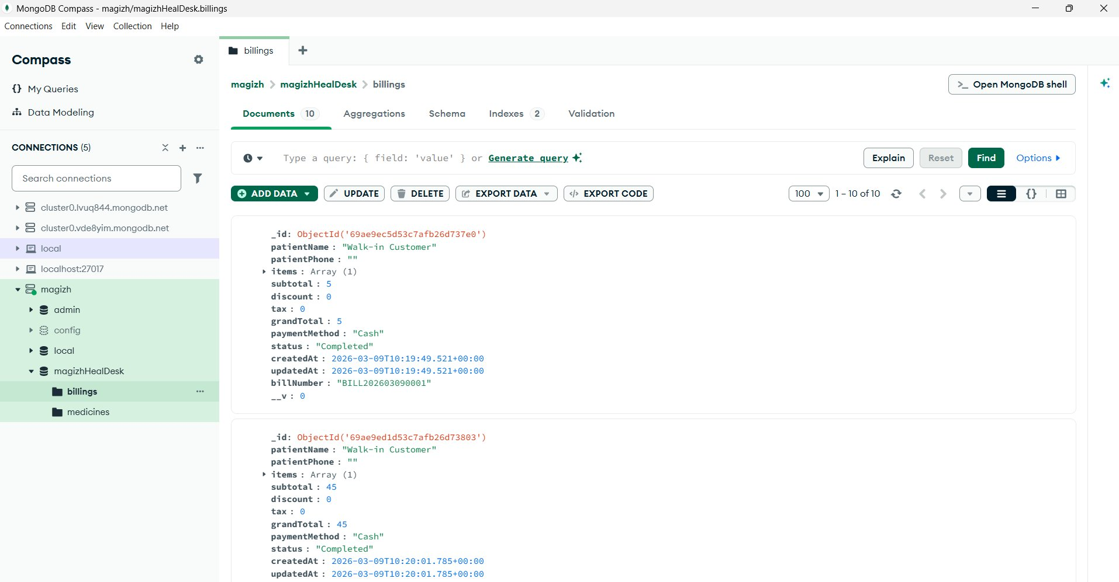
FIGURE 4.4. DATABASE SCHEMA

4.5 AI ANALYTICS MODULE IMPLEMENTATION
The Artificial Intelligence analytics module is is implemented using Groq's Llama 3.1 8B Instant model to analyze inventory and sales data and generate insights that support better decision-making within the pharmacy. This module processes real-time inventory records and historical sales data stored in MongoDB to identify patterns related to sales velocity, stock turnover, expiry risks, and demand trends. By analyzing these patterns, the system can provide useful recommendations to administrators through natural language conversations.
The AI component works by collecting relevant inventory data including medicine names, batch quantities, expiry dates, days until expiry, urgency categorizations (expired, critical, warning, good), and current stock status. When a user submits a query, the backend fetches this context and constructs a detailed system prompt with structured stock data sorted by expiry urgency. The Groq API processes the query with temperature settings optimized for factual responses and returns intelligent answers formatted with markdown tables, colored emojis for visual status indicators, and actionable recommendations
The results generated by the AI analytics module are presented through the chatbot interface in the form of conversational responses with markdown-formatted tables showing medicine names, quantities, batch numbers, expiry dates, days left, and status indicators. By integrating intelligent AI-powered analytics with the inventory management platform, the system enhances the ability of pharmacies to manage their operations in a more data-driven and proactive manner.

CHAPTER 5
SYSTEM TESTING
5.1 TESTING STRATEGY
System testing is an important phase in the development process because it ensures that the implemented application functions correctly and meets the project requirements. In this project, testing was carried out to verify that the Web Application For Magizh Medical operates reliably and performs all intended functions such as inventory management, automated billing, expiry monitoring, and AI analytics generation. The testing process focused on evaluating the system's functionality, usability, and data handling capabilities.
Different testing methods were applied during the development process to identify potential errors and improve system stability. Functional testing was conducted to ensure that each module of the application performs its assigned task correctly including medicine inventory tracking, multi-batch management, bill generation with stock deduction, and AI chatbot responses. The system was also tested for user interface responsiveness to confirm that pharmacy administrators and staff can easily interact with the platform across different devices and screen sizes. Through these testing activities, the application was verified to ensure accurate data processing, correct stock calculations, proper expiry alerts, and smooth operation.
5.2 TEST CASES
Test cases were developed to validate the major functionalities of the system. These test cases simulate real user actions such as accessing the system, entering medicine inventory data with batch details and expiry dates, adding new stock entries, updating existing records, processing customer bills with discounts and payment options, viewing low-stock and near-expiry alerts, and interacting with the AI chatbot for stock enquiries. Each test case includes the expected system response, which helps determine whether the application behaves as intended.
During testing, different scenarios were evaluated to ensure that the system handles both valid and invalid inputs effectively. For example, medicine entry forms were tested to confirm that required fields are validated and expiry dates are properly formatted. Similarly, billing functions were tested to ensure that bills are only created when sufficient stock is available, quantities are correctly deducted from batches, and unique bill numbers are auto-generated. Stock alert systems were verified to ensure expired items display proper visual indicators and near-expiry medicines are correctly categorized based on days remaining. These tests helped confirm the reliability and accuracy of the implemented system.
5.3 Results and Discussion
The testing results indicate that the developed system performs its intended functions successfully. All major modules including medicine inventory management, automated billing with stock validation, expiry monitoring with visual alerts, AI chatbot responses, and dashboard analytics were tested under different scenarios to ensure proper functionality. The system responded correctly to user inputs and successfully stored and retrieved medicine inventory and billing data from MongoDB database.
The user interface was also tested to ensure that it is easy to navigate and provides clear information to users with appropriate visual feedback. Color-coded status indicators correctly display expired, critical, warning, and good stock conditions. Blinking animations effectively highlight expired items requiring urgent attention. The AI chatbot consistently generates accurate responses with properly formatted information about medicine availability and expiry status. The billing module correctly calculates totals, applies discounts, and generates unique bill numbers while preventing over-billing beyond available stock quantities. The testing process confirmed that the system can effectively support pharmacy administrators and staff in monitoring inventory levels, managing sales transactions, and making data-driven decisions through AI-powered insights. Overall, the results demonstrate that the proposed system operates reliably and fulfills the objectives defined for the project.

CHAPTER 6

CONCLUSION AND FUTURE ENHANCEMENTS
6.1 Conclusion
The Web Application For Magizh Medical was developed to provide a digital solution for monitoring inventory activities and managing billing operations in a retail pharmacy. Traditional pharmacy operations often rely on manual record keeping, which can lead to delays, inaccuracies, expired medicine losses, and difficulties in tracking stock levels and sales data. The proposed system addresses these challenges by introducing a web-based platform that centralizes pharmacy information and allows administrators to monitor pharmacy operations more effectively.
The implemented system enables pharmacy administrators and staff to record medicine inventory with multiple batches, track expiry dates with automated alerts, process customer bills with automatic stock deduction, and maintain updated inventory records. By storing this information in a centralized MongoDB database, the system ensures that inventory and sales data is organized, accessible, and easy to analyze. The web-based interface allows users to view operational details through interactive dashboards, visual status indicators, and comprehensive reports, improving transparency and simplifying pharmacy management tasks.
An important feature of the system is the integration of an Artificial Intelligence analytics module powered by Groq AI that analyzes inventory and sales data and provides insights regarding stock availability, expiry risks, and sales trends through natural language conversations. These insights assist pharmacy managers in understanding operational performance and making better decisions related to stock procurement, discount strategies for near-expiry items, and inventory planning. Overall, the developed system demonstrates how digital technologies, automated billing, multi-batch tracking, and data-driven AI analysis can improve efficiency, reduce medicine wastage, and enhance decision-making in pharmaceutical retail environments.

6.2 Future Enhancements
Although the proposed system successfully achieves its main objectives, several improvements can be considered in the future to further enhance its functionality and performance. One potential enhancement is the integration of barcode scanning technology for faster medicine identification and billing processes. By connecting barcode scanners with the system, pharmacy staff could quickly scan medicine packages to automatically populate billing items, reducing manual entry time and minimizing errors during customer transactions.
Another possible improvement is the addition of advanced predictive analytics models that can forecast medicine demand based on seasonal trends and historical sales patterns. These models could predict which medicines will be in high demand during specific periods, identify potential stock shortages before they occur, and recommend optimal procurement quantities. Such predictive capabilities would help pharmacy managers plan inventory purchases more efficiently and avoid stockouts or overstocking situations.
Future versions of the system could also include mobile application support, allowing pharmacy managers to monitor inventory levels, receive critical alerts, and view sales reports through smartphones or tablets from anywhere. Additional features such as automated SMS notifications to customers for refill reminders, email alerts for expiring medicines, integration with supplier databases for automatic purchase orders, and multi-pharmacy branch synchronization could further enhance the usefulness of the platform. Implementation of user authentication with role-based access control would enable different permission levels for administrators, pharmacists, and support staff, enhancing security and accountability. With these enhancements, the system can evolve into a more comprehensive digital solution for modern pharmaceutical retail management capable of supporting larger healthcare chains and providing enterprise-level features.

APPENDIX 1

App.jsx
import { BrowserRouter as Router, Routes, Route } from 'react-router-dom';
import Navbar from './components/Navbar';
import Home from './pages/Home';
import Billing from './pages/Billing';
import Stock from './pages/Stock';
import Dashboard from './pages/Dashboard';
import Chatbot from './pages/Chatbot';
import About from './pages/About';
import './index.css';
unction App() {
return (
<Router>
<Navbar />
<div className="main-content">
<Routes>
<Route path="/" element={<Home />} />
<Route path="/billing" element={<Billing />} />
<Route path="/stock" element={<Stock />} />
<Route path="/dashboard" element={<Dashboard />} />
<Route path="/chatbot" element={<Chatbot />} />
<Route path="/about" element={<About />} />
</Routes>
</div>
</Router>
);
}
export default App;
main.jsx
import React from 'react';
import ReactDOM from 'react-dom/client';
import App from './App';
import './index.css';
ReactDOM.createRoot(document.getElementById('root')).render(
<React.StrictMode>
<App />
</React.StrictMode>
);
index.css
* {
margin: 0;
padding: 0;
box-sizing: border-box;
}
body {
font-family: 'Segoe UI', Arial, sans-serif;
background-color: #f0f4f8;
color: #1a1a2e;
}
.main-content {
padding-top: 70px;
min-height: 100vh;
}
.container {
max-width: 1200px;
margin: 0 auto;
padding: 30px 20px;
}
.page-header {
font-size: 26px;
font-weight: 700;
color: #0a7c5c;
margin-bottom: 24px;
border-bottom: 3px solid #0a7c5c;
padding-bottom: 10px;
}
.card {
background: #ffffff;
padding: 20px;
border-radius: 12px;
margin: 12px 0;
box-shadow: 0 4px 12px rgba(0, 0, 0, 0.08);
transition: transform 0.2s ease;
}
.card:hover {
transform: translateY(-2px);
}
.btn {
padding: 10px 22px;
border: none;
border-radius: 8px;
cursor: pointer;
font-size: 14px;
font-weight: 600;
transition: background 0.2s ease;
}
.btn-primary {
background-color: #0a7c5c;
color: white;
}
.btn-primary:hover {
background-color: #088a66;
}
.btn-danger {
background-color: #e74c3c;
color: white;
}

.btn-warning {
background-color: #f39c12;
color: white;
}
.input-field {
width: 100%;
padding: 10px 14px;
border: 1.5px solid #ccc;
border-radius: 8px;
font-size: 14px;
margin-bottom: 12px;
outline: none;
transition: border-color 0.2s;
}
.input-field:focus {
border-color: #0a7c5c;
}
.table {
width: 100%;
border-collapse: collapse;
background: white;
border-radius: 10px;
overflow: hidden;
box-shadow: 0 2px 8px rgba(0,0,0,0.07);
}
.table th {
background-color: #0a7c5c;
color: white;
padding: 12px 16px;
text-align: left;
font-size: 14px;
}
.table td {
padding: 11px 16px;
border-bottom: 1px solid #f0f0f0;
font-size: 14px;
}
.table tr:hover td {
background-color: #f5fdf9;
}
.alert-box {
padding: 14px 18px;
border-radius: 10px;
margin: 10px 0;
font-size: 14px;
font-weight: 500;
}
.alert-danger {
background-color: #ffe8e6;
border: 1.5px solid #e74c3c;
color: #c0392b;
}
.alert-warning {
background-color: #fff8e1;
border: 1.5px solid #f39c12;
color: #b7770d;
}
.badge {
display: inline-block;
padding: 4px 10px;
border-radius: 20px;
font-size: 12px;
font-weight: 600;
}
.badge-success {
background-color: #d4efdf;
color: #1e8449;
}
.badge-danger {
background-color: #fadbd8;
color: #c0392b;
}
.badge-warning {
background-color: #fef9e7;
color: #b7770d;
}
Navbar.jsx
import { Link, useLocation } from 'react-router-dom';
import './Navbar.css';
function Navbar() {
const location = useLocation();
const navLinks = [
{ path: '/', label: 'Home' },
{ path: '/dashboard', label: 'Dashboard' },
{ path: '/billing', label: 'Billing' },
{ path: '/stock', label: 'Stock' },
{ path: '/chatbot', label: 'Chatbot' },
{ path: '/about', label: 'About' },
];
return (
<nav className="navbar">
<div className="navbar-brand">
<span className="brand-icon">+</span>
<div>
<span className="brand-name">MagizhHealDesk</span>
<span className="brand-sub">PHARMACY OPS SUITE</span>
</div>
</div>
<ul className="nav-links">
{navLinks.map((link) => (
<li key={link.path}>
<Link
to={link.path}
className={location.pathname === link.path ? 'active' : ''}
>
{link.label}
</Link>
</li>
))}
</ul>
</nav>
);
}
export default Navbar;
Home.jsx
import { Link } from 'react-router-dom';
function Home() {
const modules = [
{
title: 'Billing System',
description: 'Generate accurate digital bills with automatic price calculation.',
path: '/billing',
icon: '🧾',
},
{
title: 'Stock Management',
description: 'Manage medicine inventory with expiry date tracking and CRUD operations.',
path: '/stock',
icon: '📦',
},
{
title: 'Analytics Dashboard',
description: 'Monitor low stock alerts and near-expiry medicines in real time.',
path: '/dashboard',
icon: '📊',
},
{
title: 'Stock Chatbot',
description: 'Ask about medicine availability using the AI-powered chatbot.',
path: '/chatbot',
icon: '🤖',
},
];
return (
<div className="container">
<h1 className="page-header">Welcome to MagizhHealDesk</h1>
<p className="home-subtitle">
A complete pharmacy management system for Magizh Medical. Manage billing,
stock, and analytics from a single platform.
</p>
<div className="module-grid">
{modules.map((mod) => (
<Link to={mod.path} key={mod.title} className="module-card">
<div className="module-icon">{mod.icon}</div>
<h3 className="module-title">{mod.title}</h3>
<p className="module-desc">{mod.description}</p>
</Link>
))}
</div>
</div>
);
}
export default Home;

APPENDIX 2


FIGURE 2.1. DATABASE SCHEMA

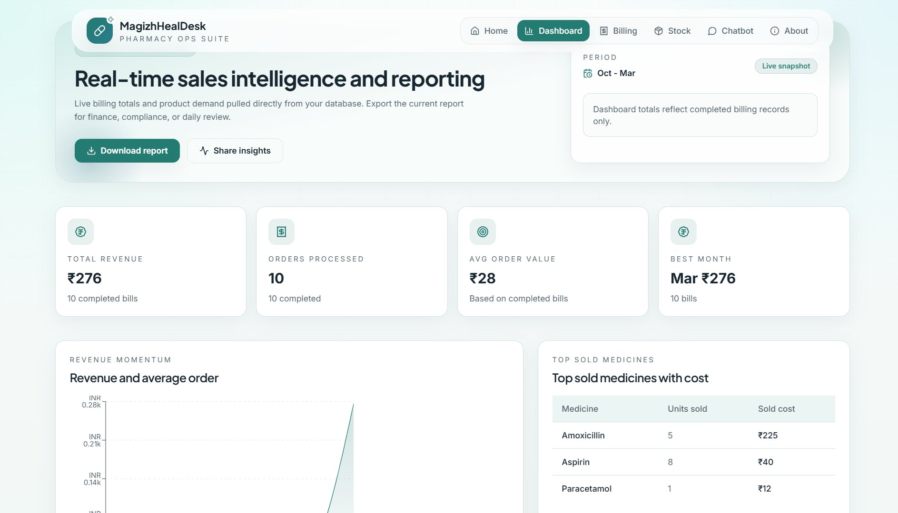
FIGURE 2.2. DASHBOARD PAGE

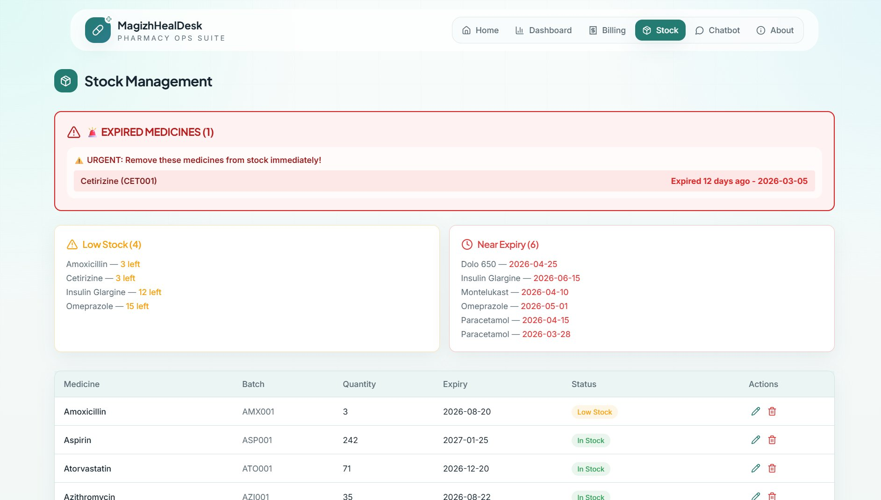
FIGURE 2.3. STOCK MANAGEMENT PAGE
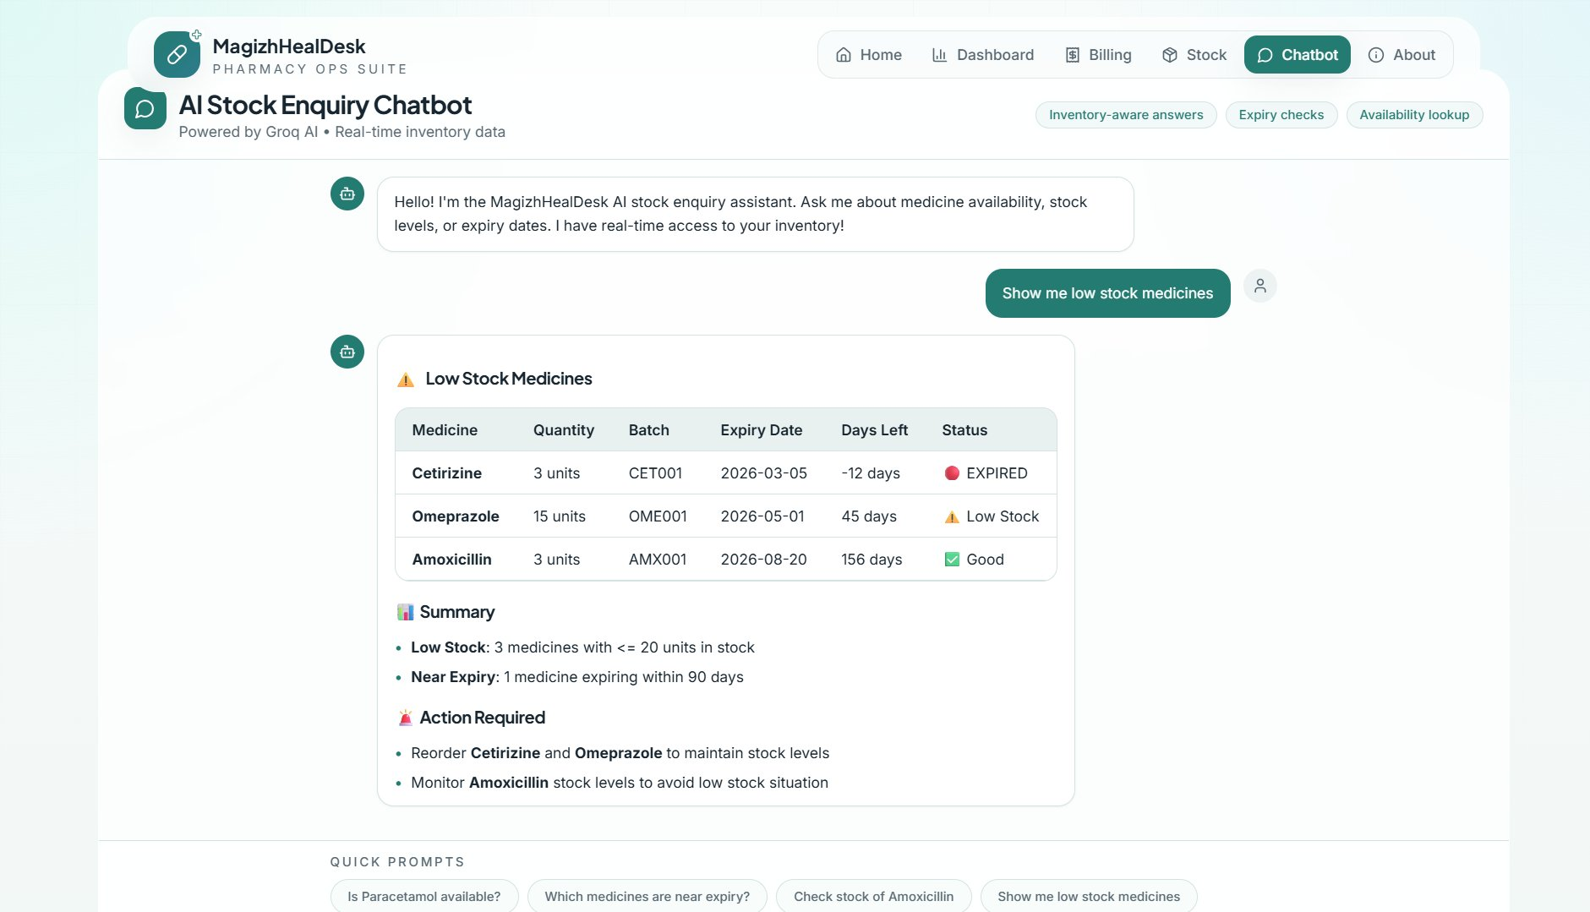
FIGURE 2.4. CHATBOT PAGE

REFERENCES

- Pressman, R. S. (2014). Software Engineering: A Practitioner's Approach. McGraw-Hill Education. 8th Edition.
- Sommerville, I. (2016). Software Engineering. Pearson Education Limited. 10th Edition.
- Flanagan, D. (2020). JavaScript: The Definitive Guide. O'Reilly Media. 7th Edition.
- Duckett, J. (2014). HTML and CSS: Design and Build Websites. John Wiley and Sons.
- Crockford, D. (2008). JavaScript: The Good Parts. O'Reilly Media.
- World Health Organization. (2019). Good Pharmacy Practice in Community and Hospital Settings. WHO Publications.
- Indian Pharmacy Act, 1948. Ministry of Health and Family Welfare, Government of India.
- Nielsen, J. (1994). Usability Engineering. Morgan Kaufmann Publishers.
- Mozilla Developer Network (MDN). Web Technologies Documentation. https://developer.mozilla.org. Accessed March 2026.
- W3Schools Online Web Tutorials. HTML, CSS and JavaScript Reference. https://www.w3schools.com. Accessed March 2026.

MAPPING OF PROJECT GOALS TO SDG

The Sustainable Development Goals (SDGs) are a set of global objectives established by the United Nations to address key challenges such as healthcare improvement, innovation, and sustainable development. The project titled Web Application for Magizh Medical contributes to the digital transformation of the healthcare sector by integrating modern web technologies, real-time data handling, and intelligent pharmacy management solutions. The system enhances operational efficiency, reduces manual errors, ensures medicine availability, and enables faster decision-making.
Under SDG No. 3 – Good Health and Well-being, the proposed system supports healthcare improvement by ensuring efficient pharmacy operations and safe medicine management through a digital platform. It enables accurate and fast billing, thereby reducing patient waiting time and improving service quality. The system ensures proper tracking of medicine stock, batch details, and expiry dates, which helps prevent the use of expired or unsafe medicines. By automating billing and inventory management, it significantly reduces manual errors. Additionally, pharmacy staff can instantly check medicine availability using a chatbot, improving response time and patient care. The platform supports continuous monitoring of stock levels to ensure that essential medicines are always available. It also improves overall healthcare service efficiency by providing a reliable and structured pharmacy management system and enhances decision-making through real-time data insights for better stock and billing management.
Overall, the implementation of this system transforms traditional pharmacy practices into a more efficient, accurate, and technology-driven healthcare support system, strongly aligning with the goals of SDG 3.

